Installing Node.js

Go to nodejs.org

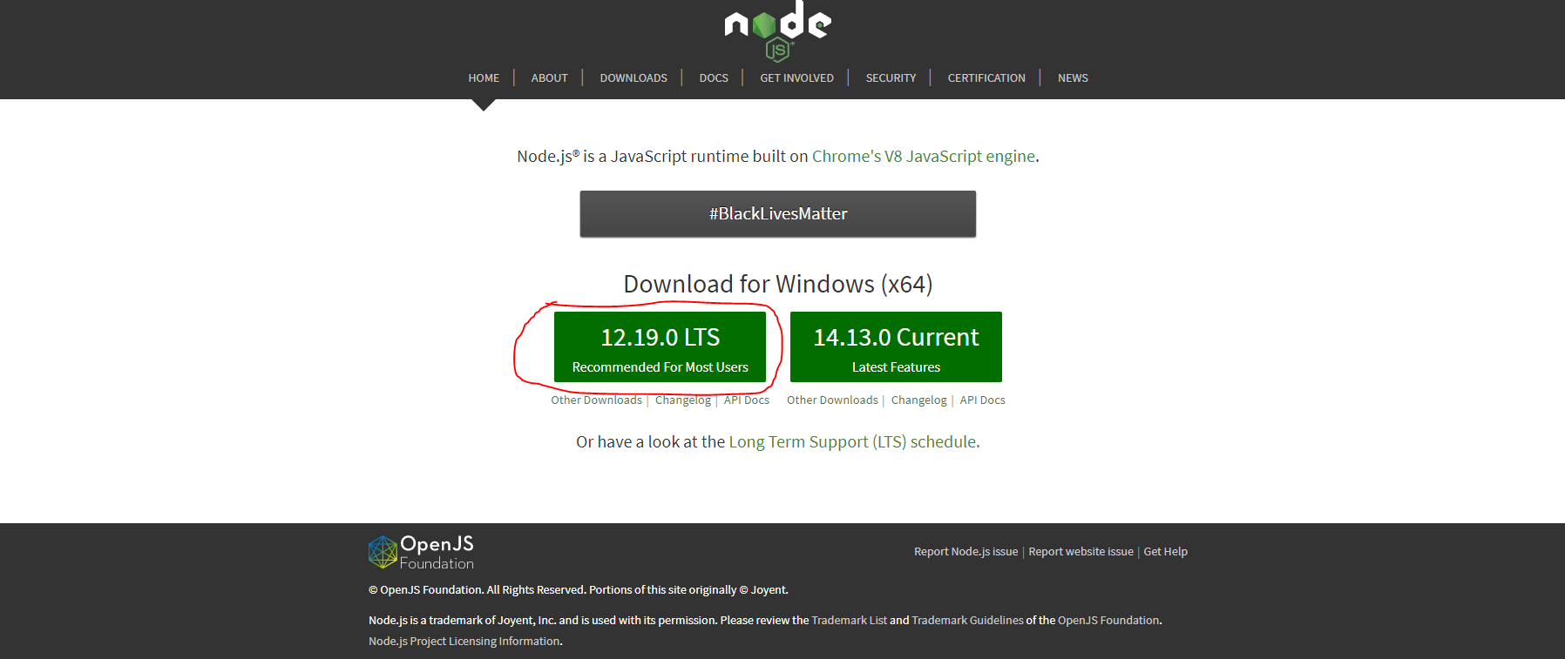

For standard version click on marked

For current Version click on beside the marked

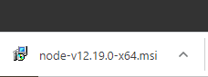

On clicking on installer

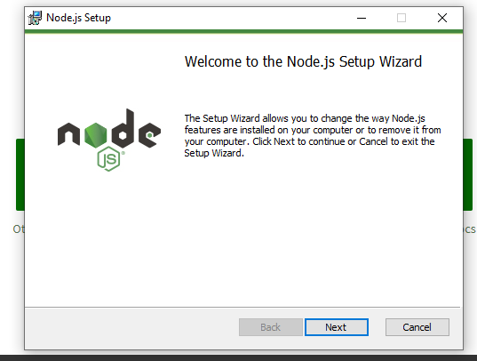

Press next and next don’t change any settings

Let them be normal.

At last press Finish and let it close

Open Command Prompt and type.

node -v

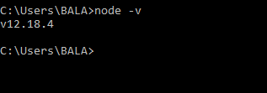

Then check the package installer version,

npm is the package manager in Node

Standards for Node Package Manager(npm)

Open Command Prompt and type.

npm -v



Now All set your Node.js is installed